Stage 5 – "Dick, you’re fired"
COURSE DESIGNER: Adam Taylor
SCORING: Comstock 26 rounds.
TARGETS: 13 cardboard targets.
SCORED HITS: 2 Best hits per carboard will be scored.

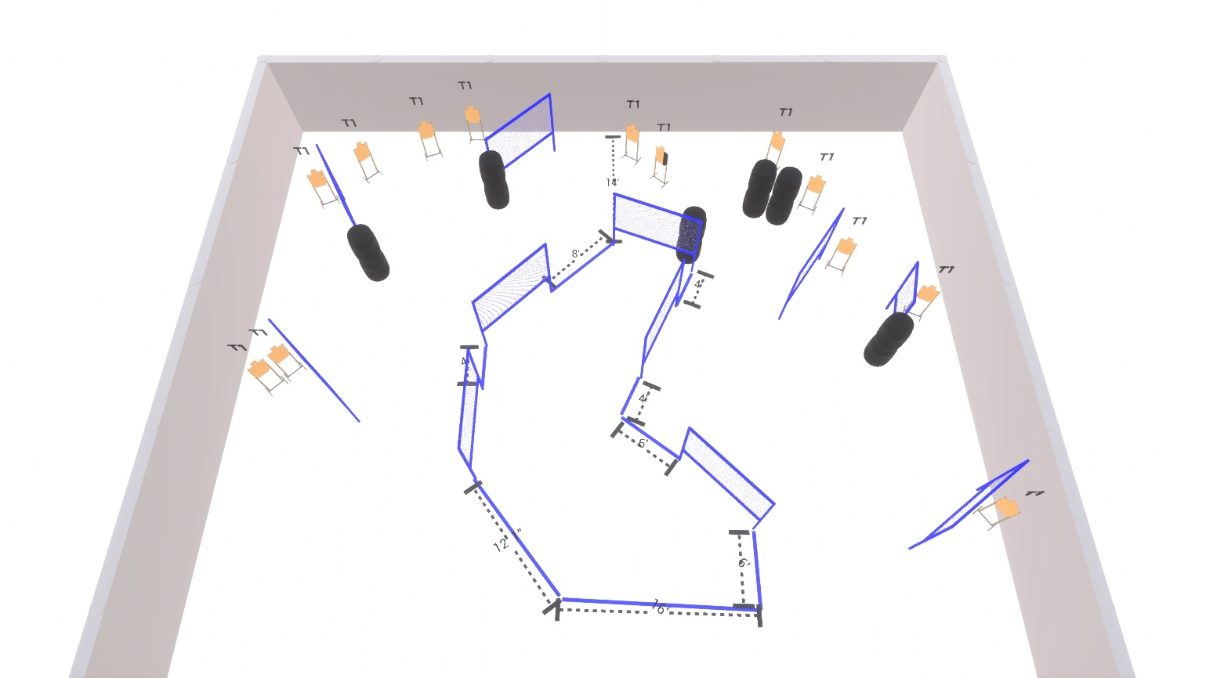

Written Stage Briefing:

Stage 5 – "Dick, you’re fired" - is a 26 round, 130 point, Comstock Course. There are 13 cardboard targets.

Starting anywhere
Handgun is loaded and holstered, wrists below belt.
PCC is loaded held in both hands, stock on belt.

On the audible start signal, engage targets from within the shooting area.

USPSA / NROI Range Commands:
- Make Ready
- Are you ready?
- Standby
- If finished, unload and show clear
- If clear, hammer down and holster (Handgun)
If clear, hammer down and flag (PCC)
If clear, cylinder closed and holster (Revolver)
- Range is clear

Setup Notes:
22 Single Wall Stands
10 Full Walls
1 Half Walls
13 Target stands / 26 target sticks
12+ Barrels



